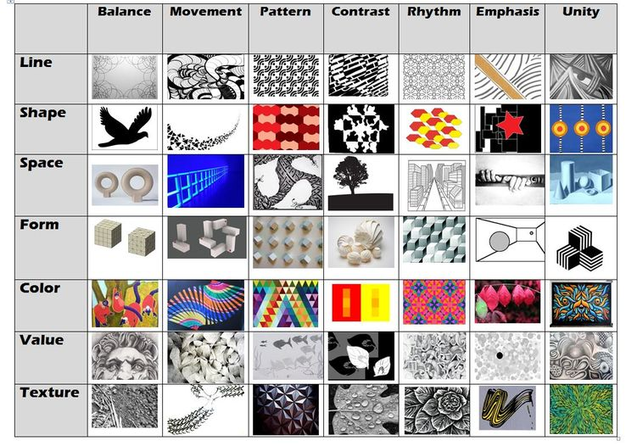**Elements of Art and Principles of Design**